Harold Ingleby Hawkins, died 16 June 1917, aged 30;
Lionel Frank Hawkins, died 17 September 1916, aged 23

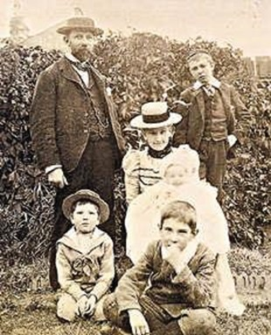
Harold and Lionel Hawkins were born and bred in East Finchley. Their parents Mary and Percy were married in St James Muswell Hill in 1884, when Mary (originally born in Leeds) was living in Fortis Green and Percy (born in Wandsworth) was living in Highgate.Their fourth son Lionel was born in 1893 at 6 Park Hall Road, just five months after his elder brother Eric had died of diphtheria at the age of five. Two more sons were to arrive, and although the older boys were baptised at St James the family’s allegiances appear to have transferred to the new All Saints’ Church when the family moved to 52 Leicester Road. Later the family moved to 27 Durham Road. Percy gives his occupation as ‘insurance clerk’, but he was presumably not in the lowest rank as he was able to afford comfortable accommodation for this growing family, and domestic help for his wife.

The Hawkins family, believed to have been taken in the garden of their home in Leicester Road in 1900.
From left to right:Percy, Lionel (about 7), Mary with baby Bernard on her lap, Geoffrey (10) and Harold (13).

Harold left school in 1902 and joined the accounts department of the Northern Assurance Company (now Aviva) and later transferred to the accident department.At some stage he learned to shoot, and he was a member of the Insurance Rifle Club and Captain and Secretary of the Alexandra Palace Rifle Club. He reached a very high standard, competing at Bisley on several occasions and winning prizes for miniature rifle shooting. In 1908 he was selected for the British team in the Olympics, held that year in London. He took part in four events and won the silver medal in small bore rifle with a disappearing target.

This battalion was one of Kitchener’s original Pals Battalions and is nicknamed the Footballers’ Regiment. Many professional footballers enlisted in it, including the entire team of Clapton Orient (later Leyton Orient) and also Walter Tull of Northampton Town, renowned as the first black officer in the British Infantry and recipient of the Military Cross. However there is no evidence that Lionel was involved in football, and in fact by the time he joined up many footballers were refusing to join the battalion so the War Office filled it with other enlistees. The battalion was sent to France in November 1915, so once Lionel completed his basic training he would have been sent out to join his fellow soldiers.

The 17th Middlesex was heavily involved throughout the Battle of the Somme, suffering heavy losses including their commanding officer. Regimental diaries are littered with evocative place names such as Delville Wood, Guillemont, Longueval Alley. They include plans, orders, reports, and casualty lists. Memos show how the officers at the front (and presumably their men) realised that much of the action was inevitably going to fail, but that they would continue to obey orders loyally. Losses were heavy and in August 716 men were sent to replenish the battalion. On 16 September 1916 the regimental diary says simply ‘Courcelles de Bois: A quiet day.2nd South Staffordshire 2 OR killed; 17th Middlesex 2 OR killed, 1 OR wounded.’ The wounded other rank was Lionel Hawkins, who died from his wounds the following day on 17 September 1916. He was buried nearby, but as the war continued his grave and/or the records were lost. His name is recorded on the Thiepval Memorial along with 72,245 other British and Empire soldiers.

Harold and Lionel Hawkins were born and bred in East Finchley. Their parents Mary and Percy were married in St James Muswell Hill in 1884, when Mary (originally born in Leeds) was living in Fortis Green and Percy (born in Wandsworth) was living in Highgate.Their fourth son Lionel was born in 1893 at 6 Park Hall Road, just five months after his elder brother Eric had died of diphtheria at the age of five. Two more sons were to arrive; Lionel (sometimes known as Leo) was educated at Christ College in Finchley, and when he left school he began studying for his qualifications with the Institute of Actuaries. He also joined the Territorial Army in the Middlesex Regiment.

By the outbreak of war in 1914 Percy was 55 and Mary 51. Harold was 27, and an insurance clerk like his father;Geoffrey was 24 and a bank clerk;Lionel was 21 and an actuarial clerk;Bernard (14 and Denis (8) were both still at school. Before the war Harold Hawkins had been a member of the Queen’s Westminster Rifles, a territorial force, but on the outbreak of war in 1914 he immediately enlisted in the 15th Battalion the London Regiment (the Civil Service Rifles).
They spent several months training in Hertfordshire, and he was promoted to Lance-Corporal on 4 February 1915, the month before being sent to France. Although the battalion was involved in several actions and Harold was commissioned during 1915 he must have had some home leave, as on 25 September 1915 he married Elizabeth Morgan at Highbury Quadrant Church. In November 1915 he was promoted again, to Captain.

At first Lionel continued his studies, becoming an Associate of the Institute of Actuaries in 1915, but some months after his eldest brother Harold enlisted Lionel decided he too had to ‘do his bit’, and he enlisted for the duration in the 17th battalion of the Middlesex Regiment in Finchley on 11 December 1915.

At the time of Lionel’s death the Civil Service Rifles were heavily involved in the Battle of Loos and other actions on the French/Belgian border. Then in 1917 they were engaged in what became known as the Battle of Arras.

On 16 June 1917 Captain Hawkins was involved in an attack on German lines between Bullecourt and Croisilles. He was wounded when the Germans counter-attacked, and was last seen lying in a forward position. Due to the severe fighting he could not be rescued, and it was hoped he would be taken prisoner and receive treatment for his wounds. Sadly no news was heard of him, and it had to be assumed he had died of his wounds. His body was never recovered and he is commemorated on the Arras Memorial.

Harold Hawkins’ widow Elizabeth returned to live with her family in Stoke Newington.She did not remarry, and died in Derbyshire in 1969, aged 83.

Harold and Lionel are both commemorated on the memorial in All Saints’ Church, and Lionel’s name is recorded on at least two other memorials – that in Christ College in Finchley, and on the Institute of Actuaries memorial in their offices in High Holborn.

Percy Hawkins, having lost three of his sons, died in April 1922 at the age of 66 in Beltinge in Kent, near Herne Bay The rest of the family were still living in London, so perhaps Percy was suffering poor health and had gone there to benefit from the sea air.Two years later Bernard went to Canada to start a new life. Mary lived on until 1950, dying in Muswell Hill where Denis lived; he was listed as an insurance inspector, so he too had a similar career to his father and elder brothers. Geoffrey died in 1977 in Stepney.

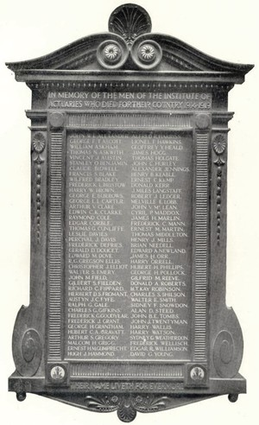

The War Memorial for the Institute of Actuaries – Lionel Hawkins’ name is the second on the right hand column.

